
SDM Project Builder Tutorial

SDM Project Builder automates the initial setup of a watershed modeling project from a user-specified area of interest. This tutorial is designed to assist a new user learning to use the SDM Project Builder software, including the GIS interface.

Question addressed in this tutorial:
- How do I start the SDM Project Builder?
- What are the components of the SDM Project Builder User’s Interface?
- How do I navigate the SDM Project Builder GIS environment?
- How do I select an area of interest?
- How do I build a watershed modeling project for the area of interest?

  - Introduction to the SDM Project Builder

QUESTIONS ANSWERED:
- How do I start the SDM Project Builder?
- What are the components of the SDM Project Builder User’s Interface?

- From the Start menu, under Programs, select SDMProjectBuilder inside the SDMProjectBuilder group. The following window will open:

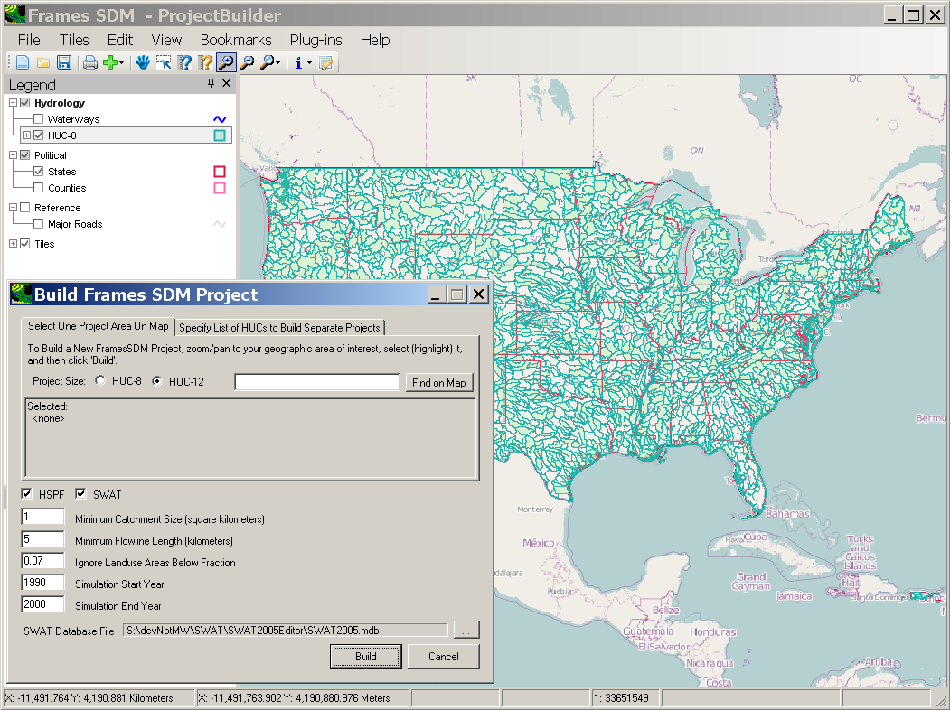

Note: In the map image above, the entire continental United States is displayed. The next time SDM Project Builder is run, the software will begin with the map positioned as it was the last time a project was built.

- The SDM Project Builder User’s Interface includes 2 main components: an interactive map of the Continental US, and a specification window showing parameters governing the model simulations to be created. The map includes capabilities to pan, zoom in and out, turn layers on/off, as well as control the appearance of layers on the map. The specification window shows names of selected features, which models to set up, and a few parameters governing the model simulations to be created.

- Navigating the SDM Project Builder GIS Environment

QUESTION ANSWERED:
- How do I navigate the SDM Project Builder GIS environment?

The SDM Project Builder is built upon a lightweight open-source Geographic Information System (GIS) known as MapWindow (www.mapwindow.org). Because GIS combines mapping tools with a data management system, it provides the integrated framework necessary to bring modeling tools together with environmental spatial and tabular data. The user interface component of SDM Project Builder containing the map is the SDM Project Builder GIS environment.

Within the SDM Project Builder GIS environment there are three distinct panels. The most prominent one is the map itself. To the left of the map is the legend showing which layers are currently available and/or displayed on the map. In the bottom left corner is the preview map providing an image of the map zoomed to the full extent of all layers. The preview map can be used to orient you within the many map layers.

Sets of layers in the map legend are combined into logical groups. For instance layers pertaining to hydrology are listed in a group labeled ‘Hydrology.’ Similar groups exist for Political Boundaries and Reference Layers.

- The States layer is currently “on” because the box is checked next to its name. Click the check box next to States to turn this layer “off.” Notice that when you do so, the red lines disappear from the map.

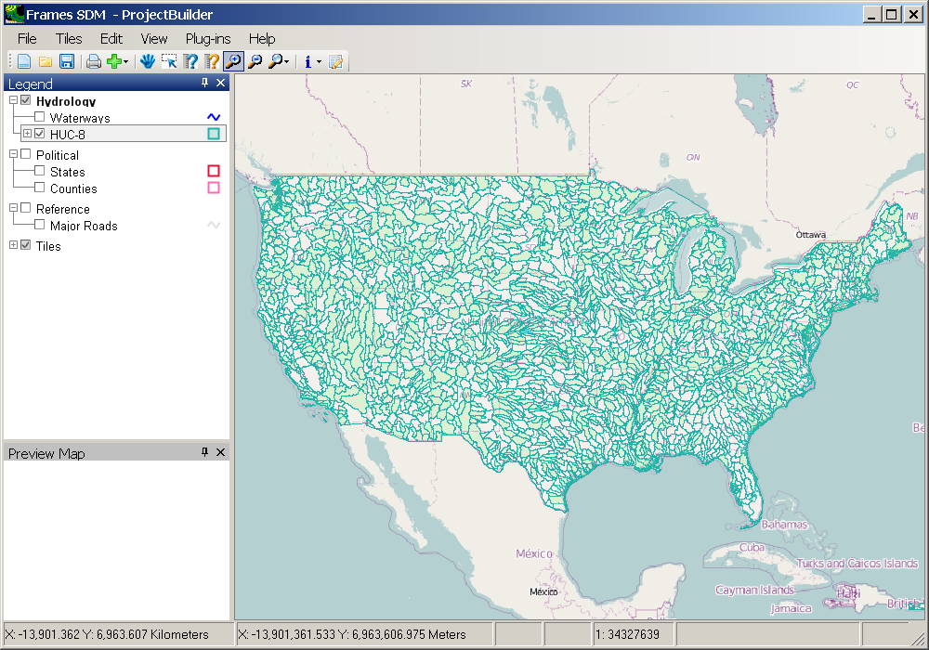

- Now turn it back “on” by clicking the check box again.

- Notice that the HUC-8 name in the legend is shaded and surrounded by a box (see figure below). This means the layer is “active.”

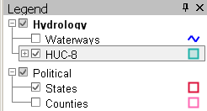

Zooming Tools

SDM Project Builder has typical GIS tools for zooming in and out:

(Zoom In tool) (Zoom Out tool)

- Click (Zoom In tool).

- Drag a box on the map around the area you would like to zoom to.

Note: To drag a box on the map, first depress and hold the left mouse button on the NW corner of box you would like, and drag the mouse to the SE corner of the box before releasing the mouse button.
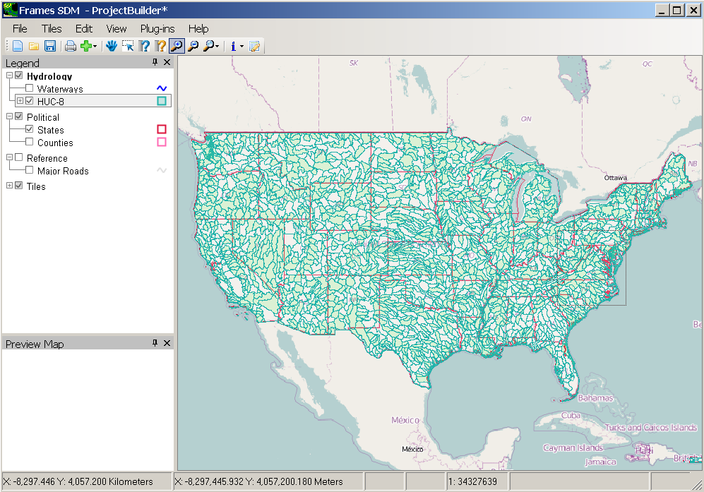

Notice that the map zooms into that area.

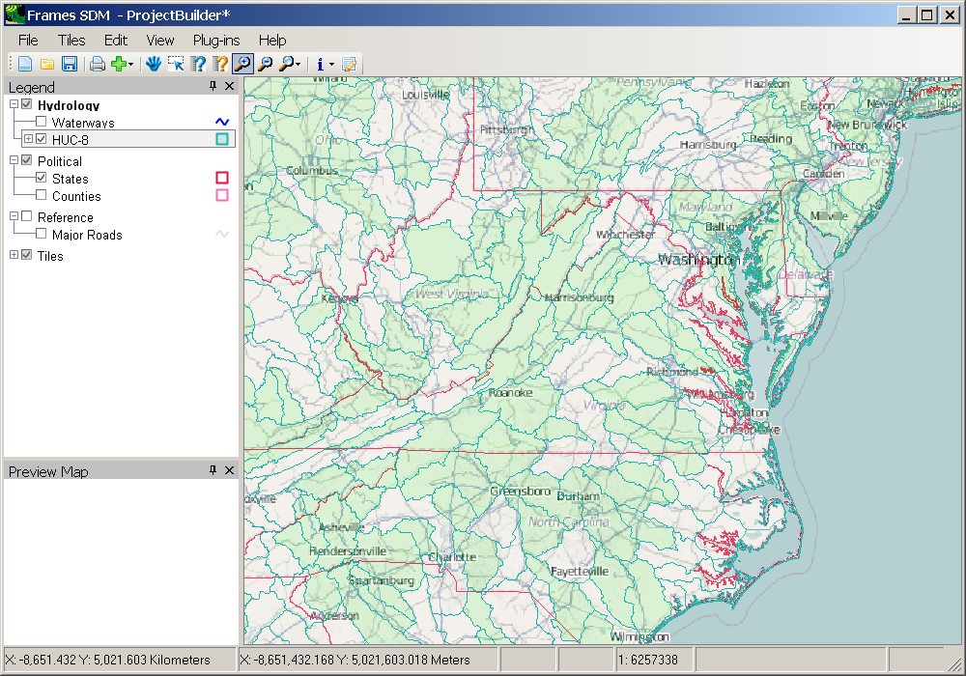

- Click on the View menu and select “Previous Zoom.” This will return the map to the full extent of the continental United States.

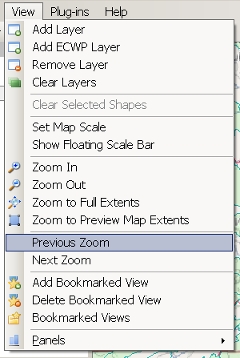

Table Editor Tool

SDM Project Builder has a “Table Editor tool” that allows you to view and edit the attributes associated with map features.

- Make the HUC-8 layer “on” and “active.”

- Click (Table Editor tool). The “Attribute Table Editor” will appear. It displays the attribute table associated with the “active” layer.

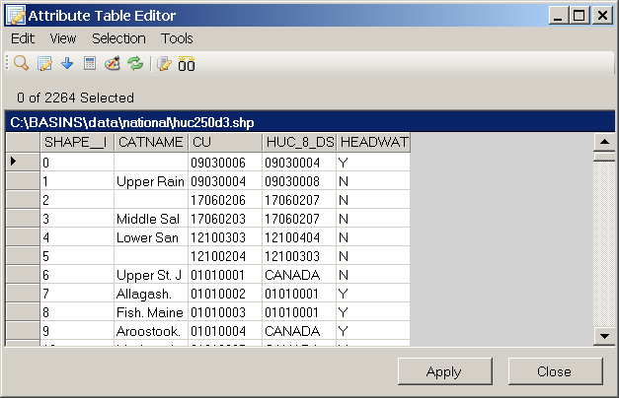

- Scroll down and select a cell in the left-most column of the table. The feature corresponding to the row you selected will be highlighted in yellow on the map.

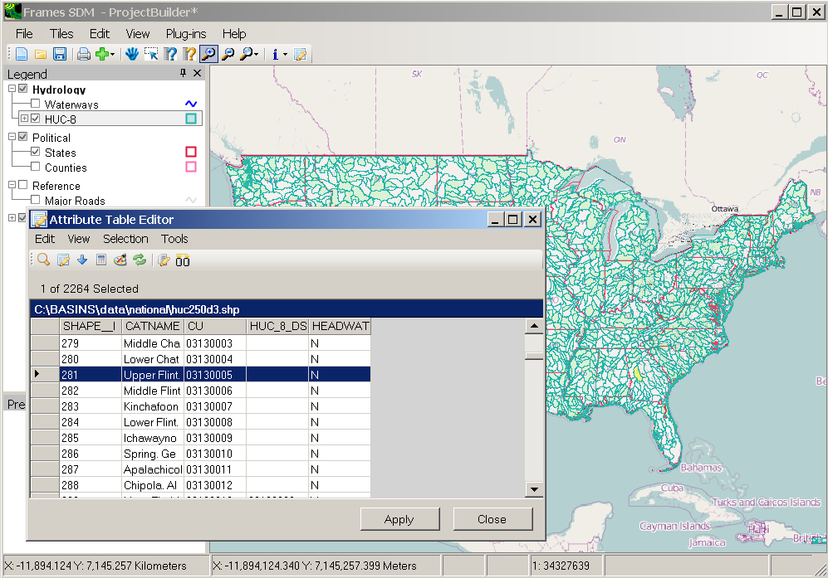

- Close the “Attribute Table Editor” window.

- Building a Watershed Modeling Project for an Area of Interest

QUESTIONS ANSWERED:
- How do I select an area of interest?
- How do I build a watershed modeling project for the area of interest?

Within SDM Project Builder, an area of interest may be specified as either a HUC-8 (sometimes known as a Cataloging Unit) or a HUC-12. Since the process of building a project can take some significant time for a HUC-8, in this tutorial we will build a project for a HUC-12.

In order to select a HUC-12 within the SDM Project Builder, one must first select a HUC8. Once a HUC-8 is selected, the corresponding HUC-12 layer is automatically added to the map, and the user may choose from the available HUC-12s.

In this section we will select a HUC-8, and then within that HUC-8 a HUC-12 for this project. Once we have our HUC-12 selected we will build a watershed modeling project for that HUC-12.

1. Click (Zoom In tool). Using the “Zoom In” tool, zoom into the area near the states of Virginia and Maryland.

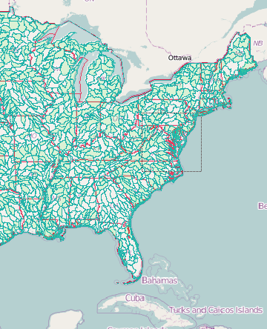

- Make the HUC-8 layer “on” and “active.”

- Click (Select Feature tool).

- Using the map image below for reference, click the Patuxent Watershed (Cataloging Unit number 02060006). Notice that the description of the selected feature(s) appears in the “Build Frames SDM Project” window.

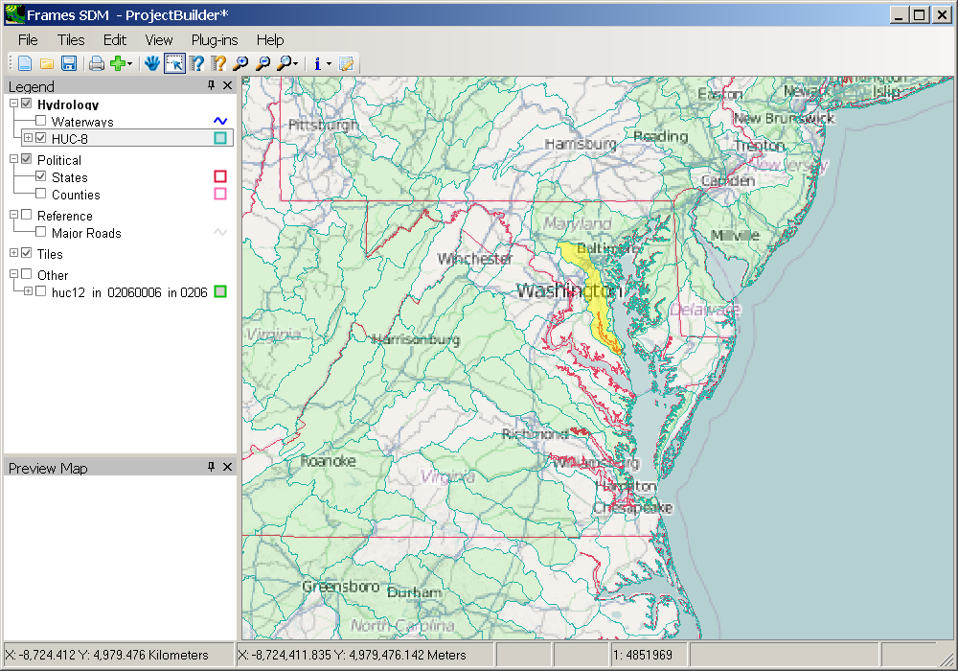
Select only one HUC.

- Notice that the HUC-12 layer for the selected HUC-8 loads automatically.

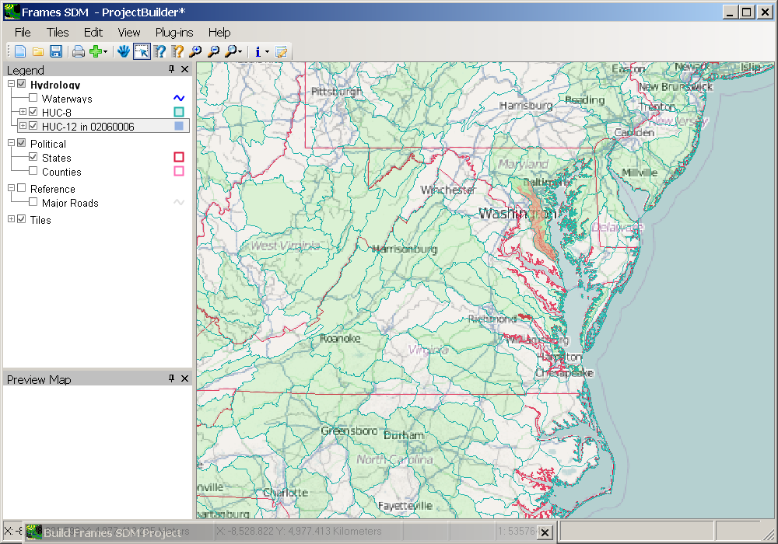

- We will zoom in on the newly added HUC-12 layer. Right-click on the HUC-12 layer in the Legend and select the Zoom to Layer option.

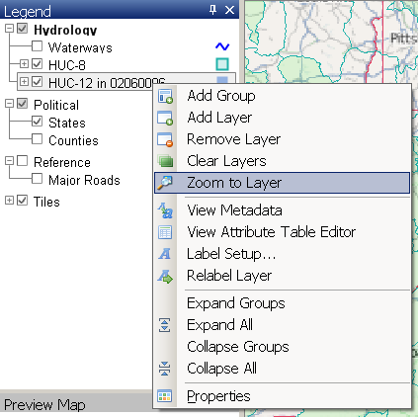

- The resulting map will appear as in the following image:

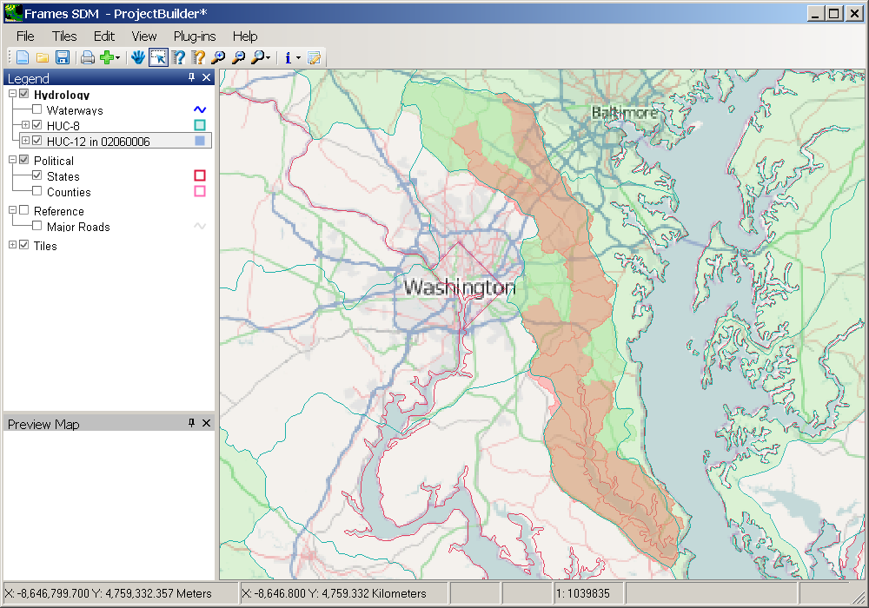

Note: The HUC-8 boundaries do not align exactly with the NHC-12 boundaries because these two map layers are from different sources with different resolutions. As used in this software, these layers are for selection purposes only (the NHDPlus layer, with its smaller catchment size, is eventually used to define the boundaries within the watershed models), so the slight differences between these boundaries are immaterial.

- In order to make the HUC-12 layer stand out visually, we will adjust the map appearance. Click off the HUC-8 layer and the Tiles.

- Click the ‘+’ on the HUC12 layer in the legend to show the symbology for this layer. The resulting map will appear as follows:

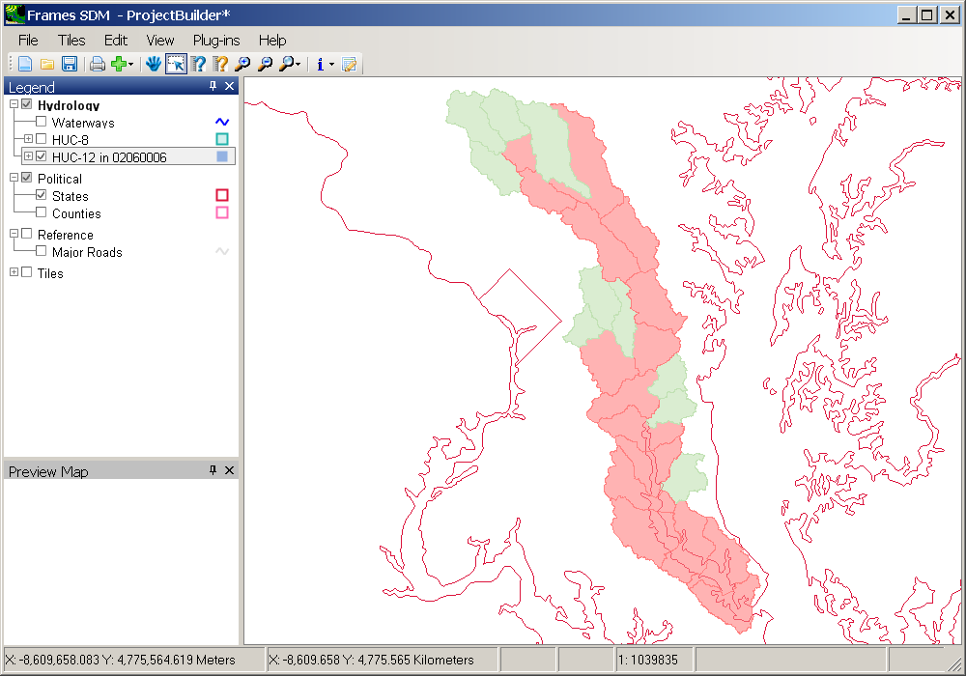

Note: The colors of the HUC-12 polygons indicate which of them represent headwaters. Notice that the headwater HUC-12s are colored green. The green headwater HUC-12s are appropriate for selection in this SDM Project Builder tool. The red non-headwater HUC-12s may be selected, but it must be understood that selecting a non-headwater HUC-12 will result in a watershed model that does not properly represent upstream flow into the selected HUC.

- Click (Select Feature tool).

- Click the Collington Branch Watershed as shown below:

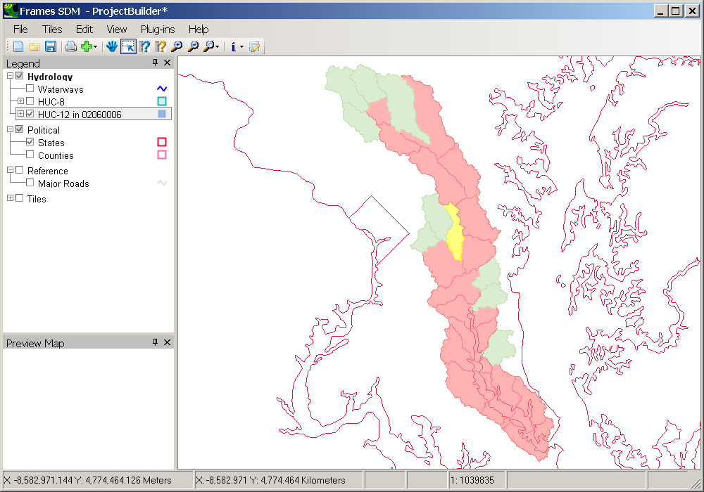

- Notice that Collington Branch is shown as the Selected Feature in the Build New SDM Project window.

The Build New SDM Project window contains a small set of parameters for the user to control the watershed models to be created. The HUC-8/HUC-12 radio buttons specify whether the project to be built should be for the selected HUC-8 or HUC-12. With the HSPF and SWAT check boxes, the user specifies which of these models will be created (checking both leads to both HSPF and SWAT models being created).

The Minimum Catchment Size, Minimum Flowline Length, and Ignore Landuse Areas Below Fraction fields provide a way for the user to control the size and number of computational units in the resulting model. These values will determine the number of subbasins and stream segments that will result from the subsequent delineation process and will impact the run time in the models. For Minimum Catchment Size, 1 square km is a reasonable lower limit for most modeling applications. For Minimum Flowline Length, a stream length between 1 and 4 km is reasonable for most modeling applications using a HUC-12, and a stream length between 8 and 14 km is reasonable for a HUC-8.

The Ignore Landuse Areas Below Fraction field allows the user to prevent creation of a SWAT modeling unit (HRU) of a very small area. If a land use makes up a fraction of a subbasin smaller than this specified threshold, the area of the corresponding modeling unit will be assigned proportionally to the other modeling units within that subbasin. The default value of 0.07, or 7%, may be adjusted as desired. The Simulation Start Year and Simulation End Year fields are used to specify the starting and ending dates of the simulation.

- For this example, turn off the HSPF check box (the HSPF feature is not yet fully implemented) and change the Minimum Flowline Length to 4 kilometers:

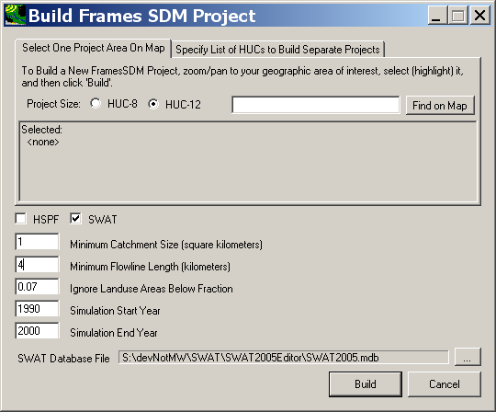
- Now click ‘Build’.

- By default the new project will be named according to the HUC-12 identifier. Accept “020600060303.mwprj” as the new project file name.

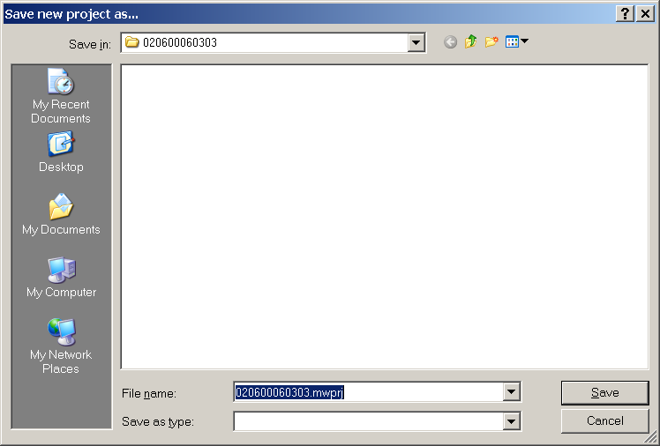

Note: On subsequent runs of the SDM Project Builder, if the user wants to build another project for the same HUC (e.g., perhaps using different values for inputs parameters such as minimum stream length), the new project name will consist of the HUC number followed by an appended counter, such as "020600060303-2.mwprj”, "020600060303-3.mwprj”, etc.

- Click SAVE.

At this point the data will be downloaded, extracted, projected, and otherwise processed to create the watershed modeling projects specified. Wait while this process proceeds.

During this process a status monitor will display progress:

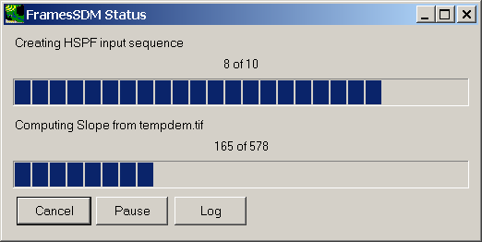

When complete, the status monitor will indicate that the process is finished. (This window may be closed by clicking the ‘X’ in the top right corner.)

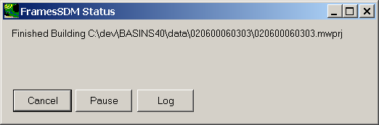

The GIS layers for the new project will be displayed in the GIS interface:

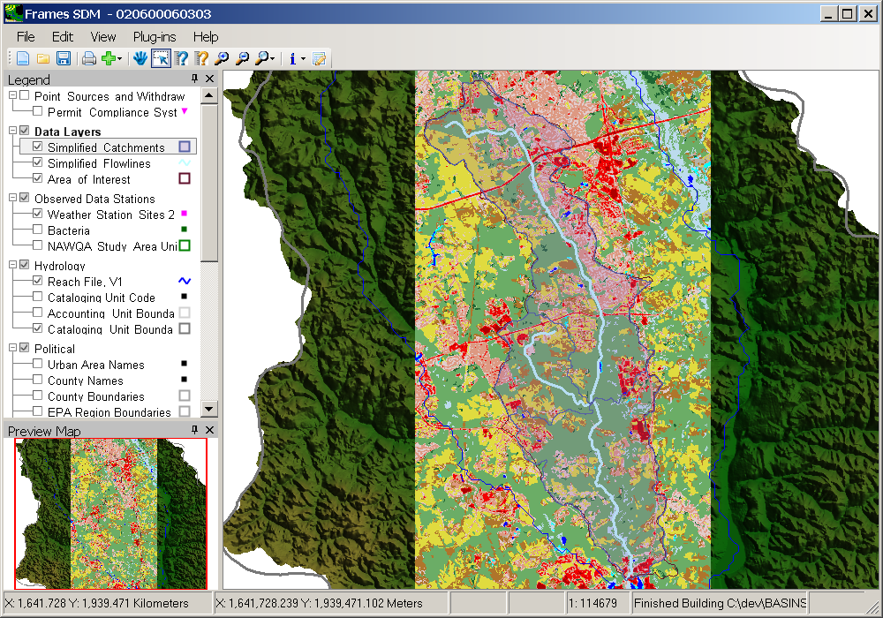

The GIS layers may be explored through the GIS interface. Note that the Simplified Catchments and Simplified Flowlines layers represent the catchments and stream segments used in the watershed and surface water models.

- When finished exploring the map layers, the project may be closed. Click on the File menu, and select the Exit menu option.

NOTES

Directory Structure and Folder Contents

SDM Project Builder is installed in a folder specified by the user during the installation process. The default name of this folder, known as the base folder for the installation, is SDMProjectBuilder, and by default it is created in C:\.

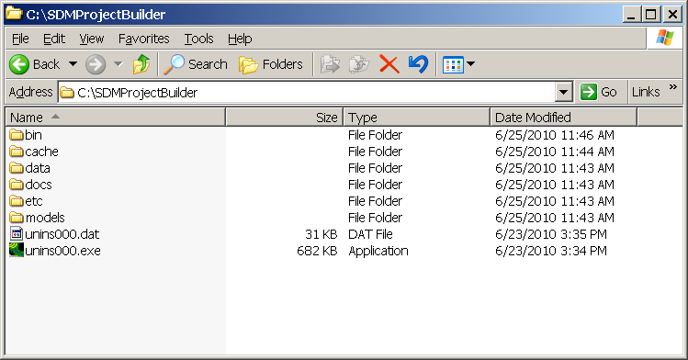

Within this folder are subfolders – bin, cache, data, docs, etc, and models. The details of the contents of each of these subfolders are provided in this section.

bin The bin folder contains the executables and associated libraries for SDM Project Builder. The user has no need to edit or change files in this folder.
cache The cache folder contains copies of information downloaded from the internet during the building of a project. Subfolders are created for log files and each download type. When the user requests SDMProjectBuilder to build a new project, the cache folder is checked to see if any required data has previously been downloaded. If appropriate data is available in the cache folder, the downloading step is skipped. The user may delete data in the cache folder in order to free up disk space.
data Files downloaded and created during execution of the SDM Project Builder are stored in the data folder within the base folder. More details regarding the content of the data folder are provided in the following section. There is an additional folder within data named national. This folder contains the map layers used to help the user specify the area of interest.
docs The docs folder contains the documentation associated with SDM Project Builder.
etc The etc folder contains other files written during the installation of SDM Project Builder. The user has no need to edit or change files in this folder.
models The models folder contains supporting files related to specific model packages placed during installation. The user has no need to edit or change files in this folder.
Additionally, configuration information for SDMProjectBuilder is stored in files found in ‘C:\Documents and Settings\<username>\Application Data\SDMProjectBuilder’. The user should have no reason to edit any files found in this folder.
If SDMProjectBuilder is being used in a FRAMES context, consult the FRAMES documentation for possible updates to file locations.

Contents of the Data Folder

Files downloaded and created during execution of the SDM Project Builder are stored in the data folder within the base folder. Within that data folder, the project data will be stored in a subfolder with the same base name as the project (i.e. the project folder). In other words, for a project named 020600060303 with SDM Project Builder installed at C:\SDMProjectBuilder, files associated with this project will be stored in the project folder C:\SDMProjectBuilder\data\020600060303.

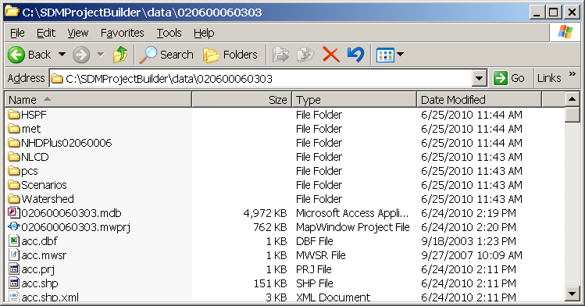

The project folder contains the map layers downloaded and processed with the BASINS core data. In addition, this folder contains the MapWindow project file, SWAT Access database, the SWAT grid of HRUs, and intermediate reports from geoprocessing.

Also within the project folder will be a number of subfolders representing each download and model input type. The following lists the subfolders along with a brief description of the contents of each:

HSPF stores the files associated with the new HSPF watershed model (.UCI and .WDM)

log stores a log of information related to the automatic download and projection of BASINS data

met contains the map layer representing the location of the meteorological data and WDM file containing the meteorological data

NHDPlus contains the downloaded and processed NHDPlus hydrography layer, catchments layer, and elevation grid; along with the simplified hydrography and catchments produced during the SDM Project Builder processing based upon the input parameters chosen

NLCD stores the grid of land cover data used in building the watershed models

PCS a subfolder containing point source data, placed during extraction of the BASINS core data

Scenarios stores the subfolders and data files associated with the new SWAT watershed model

Watershed stores the subfolders and map layers associated with the new SWAT watershed model

Troubleshooting and Debugging Information

If an SDMProjectBuilder run does not produce the expected model input sequences, the first step to determining the cause of the problem is a review of the log file. Log files are found in the \SDMProjectBuilder\cache\log folder. Each log is named with the time that the run began. The log file may be placed on the iemHUB for consideration by the developers.

Additional MapWindow Details

For more detailed information about all of the MapWindow features and functions, consult the following resources:

MapWindow User's Guide http://www.mapwindow.org/wiki/index.php/MapWindow:Desktop

MapWindow Quick Start Tutorial and Application Tutorials
http://www.mapwindow.org/tutorials/

